Game Design Document

Fill up the following document

1. Write the title of your project.

Running from Corona

1. What is the goal of the game?

The goal of the game is to try to escape from the consequences of falling into the hands of the vast pandemic, corona.

1. Write a brief story of your game.

The story of my game is to potray of a man,Mr. Johnson, whose entire family have been inflicted by the dangers of covid-19. This man tries to escape regardless situation going on at home. Not only his family but his entire society as well. As he escapes, the sick are in desperate need of this man’s help due to his stong immunity . But, the man refuses to even call the doctor and goes through obstacles in the game which symbolizes the struggles and precautions from being captured by the millions of germs and bacteria within this air-borne and contagious disease. Mr. Johnson finds a gun with limited ammunition to destroy the numerous pathogens. At last, the game conveys feedbacks to alert the player of their progress.

1. Which are the playing characters of this game?

* Playing characters are the ones who respond to the user based on the input from the user.
* Cars, monkeys, dinos, wizards, etc., are the playing characters in the game.

|  |  |  |
| --- | --- | --- |
| Number | Character Name | What can this character do? |
| 1 | Mr. Johnson | The character can interact within the game by being controlled to jump on either the left or rigth side to achieve his/her goal. |
| 2 |  |  |
| 3 |  |  |
| 4 |  |  |
| 5 |  |  |
| 6 |  |  |
| 7 |  |  |
| 8 |  |  |

1. Which are the Non-Playing Characters of this game?

* Non-Playing characters are the ones that don't have an action or behavior when the user interacts with the game.
* Hurdles, stones, bananas, coins, etc., are non-playing characters in the game.

|  |  |  |
| --- | --- | --- |
| Number | Character Name | What can this character do? |
| 1 | Covid-19 disease (pandemic) | Chases Mr. Johnson |
| 2 | Obstacles | Tries to stop Mr. Johnson from espcaping |
| 3 | Checkpoint doors | Doors which gives an indirect feedback to the player on their progress throughout the game |
| 4 |  |  |
| 5 |  |  |
| 6 |  |  |
| 7 |  |  |
| 8 |  |  |

Draw your imagination of this game. What does this game look like?

* Draw the game either on your computer or on paper.
* Add images of the game scenes to show each of the playing and non-playing characters at least once.

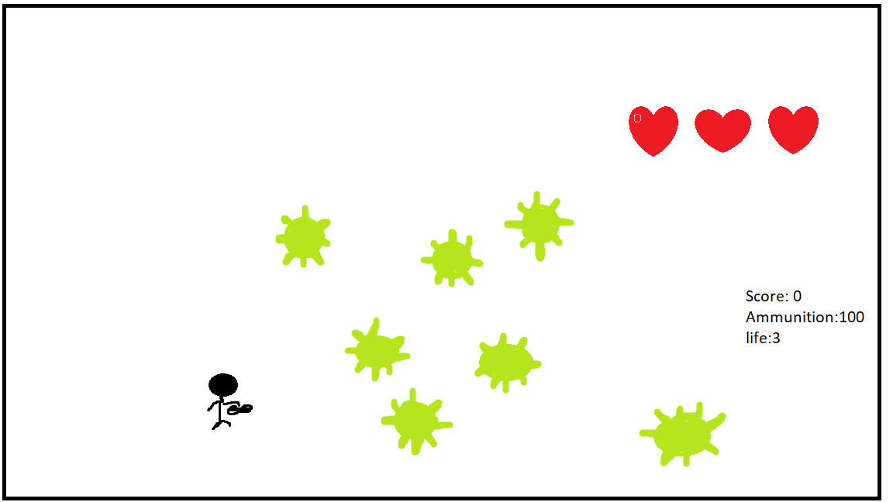

How do you plan to make your game engaging?

Mr. Johnson has luckily found a gun to destroy the pathogens but will only be given limited ammunation. The number of bullets in his gun will only by 25. Furthermore, he only has THREE chances to escpae and win this treachorous nightmare. There will be a score feedback at the right in which the man can escape only is he hasa score of 20. The other feedbacks to enhance and make the game engaging are that a sound of bullets firing from a gun will be heard once released from the gun. Once these bullets kill the pathogen another sound effect will be heard and the player’s score increases where a sound can be heard once again.